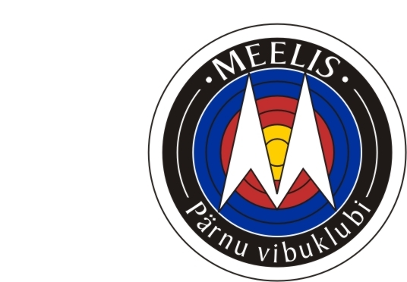

Pärnu Vibuklubi Meelis, Tammiste tee 6A,
Pärnu, Estonia,

Meelis Cup 2010
05-08/08/ August-Pärnu

PROGRAM

THURSDAY 05/08/2010 Arrival of teams

Friday 06/08/2010
16.00 p.m.- 20.00 p.m. Official Practice & Equipment Control
17.00 p.m.. Team Captains Meeting
20.05 p.m. Opening Ceremony- On the Field
Saturday 07/08/2010 Qualifications Round 2 x 70m
MEN AND WOMEN OLYMPIC /COMPOUND
10.00 a.m- 10.45 a.m. Practice
11.00 a.m. Competition
Sunday 08/08/2010 MEN AND WOMAN OLYMPIC/ COMPOUND
Individual Elimination & Final Round
Team Competition
9.00 a.m. – 9.45 a.m. Practice Men and Woman ( if there is space then
others can practice also)
10.00 a.m. Individual Elimination & Final Rounds
Team Final Rounds
Award Ceremony – Closing Ceremony

Entry fee: 20 eur/ per person
Contact:
Leili Kukk sl@lv.parnu.ee +372 5274096
Eimar Kukk eim_63@hotmail.com +372 55669416

